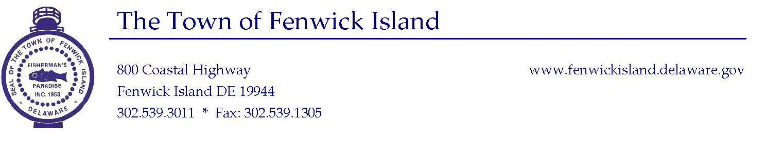
Created. March 2017
Administrative Position
35, 37.5 or 40 hour week

ADMINISTRATIVE ASSISTANT

General Statement of Duties:
The Administrative Assistant reports to the Town Manager. This position involves the practice of excellent organization, computer, business and communication skills.

Distinguishing Features of the Class:
The work of this class involves the performance of supervised general office duties, light bookkeeping, organizational and communication skills. Employees of this class must be capable of working without immediate supervision and to exercise decision-making ability within the realm of responsibilities assigned by the Town Manager.

ADA Requirements:
This is sedentary work requiring the exertion of up to 10 pounds of force occasionally and a negligible amount of force frequently or constantly to move objects; work requires reaching, fingering, grasping and repetitive motions. Vocal communication is required for expressing or exchanging ideas by means of spoken word and conveying detailed or important instructions to others accurately, loudly or quickly. Hearing is required to perceive information at normal spoken word levels and to receive detailed information through oral communication and/or to make fine distinctions in sound. Visual acuity is required for preparing and analyzing written or computer data, operation of machines, determining the accuracy and thoroughness of work and observing general surroundings and activities. The worker is not subject to adverse environmental conditions.

Essential Duties and Responsibilities
- Serves as Town Hall Administrative Assistant and Receptionist;
- Functions as a coordinator of meetings, events and activities related to municipal business. This includes, but is not limited to preparation and timely publication of notices and agendas, maintaining the calendar of Town Hall activities updating the town sign and web site;
- Takes and transcribes meeting proceedings in which several speakers participate, or takes and transcribes difficult dictation involving technical terminology;
- Prepares responses to correspondence from dictated notes or on own initiative;
- Screens visitors, telephone calls and incoming mail;
- Answers inquires which in the employee’s judgment do not require the supervisor’s attention;
- Establishes and maintains complex files, cross-reference files and establishes file categories;
- Handling requests for public records under FOIA regulations;
- Notifies staff members of meetings;
- Types complex statistical and account reports requiring a number of separate tabulations;
- Searches files and a variety of source material for reports;
- Reviews outgoing mail prepared by other clerks for form, accuracy and adherence to office policy;
- provides public information by producing posters, flyers, the Fenwick Island Newsletter (FIN) and the town web site;
- Maintains the accuracy of essential records;
- Attends council meetings and committee meetings as requested by the City Manager;
- Prepares payroll, purchase orders, leave requests;
- Maintains personnel files;
- Prepares or assists in preparing preliminary budgets;
- Organizes projects, researches issues;
- Assists in the preparation of purchase orders, account reconciliation and benefits processing;
- Processes pension and health care documentation;
- Performs as back-up Notary to Town Clerk;
- Performs other duties as assigned by Town Manager

ADMINISTRATIVE ASSISTANT POSITION DESCRIPTION

Required Knowledge, Skills and Abilities:
Knowledge of office terminology, procedures and equipment including but not limited to telephone switchboard, adding machine and personal computer is required. Working knowledge of software used by this office for purposes of correspondence and analysis (e.g. Microsoft Word, Outlook and Excel) is required. Demonstrable skill in business math, reading, speaking and writing, and light bookkeeping is required. The position requires the ability to work effectively with other employees and the public. Courtesy, tact and discretion are necessary to convey an appropriate amount of information to associates and the public. A willingness to adapt to new office procedures and to accept assignments is needed. Dependable and timely attendance of job duties, as scheduled, is essential.

Specialized knowledge in the area of municipal operations is essential. This includes, but is not limited to, the Freedom of Information Act and legal requirements for the retention of records. The candidate for this position must be able to effectively communicate matters of legal or technical consequence to citizens, their authorized agents (mortgage companies), the Town Manager and the Town Council. Confidentiality and discretion in communication are critical.

The position requires the handling of cash, making bank deposits and the recording of receipts. Candidates must meet bonding requirements.

Acceptable Experience and Training:
Completion of standard high school coursework or a Graduate Equivalency Diploma including or supplemented by courses in business practice and management, and considerable responsible senior administrative experience; or any equivalent combination of experience and training which provides the required knowledge and skills and abilities.

Additional Requirements:
Possession and retention of a valid motor vehicle operator’s license. Must pass testing for substance abuse and criminal background investigation. Must maintain a positive work environment by acting and communicating in a manner that promotes harmonious relations with customers, co-workers, and supervisors. Direct deposit of pay required.

