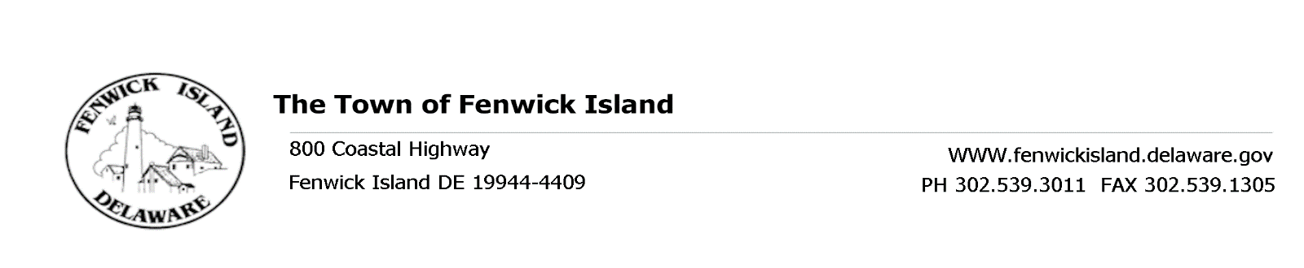
REGULAR MEETING OF THE TOWN COUNCIL
July 22, 2016, at 3:30 p.m.
Town Hall

AGENDA

Flag Salute and Call to Order
- President’s Report
- For Discussion and Possible Action:
  - Special Events Permit – 2016 Lifeguard Awards Town Manager Burke
  - Town Beach End Maintenance Public Works Supervisor Reed

- Approval of Minutes from June 17, 2016 Regular Council Meeting
- Treasurer’s Report
- Town Manager’s Report
- Department Reports: Building, Public Works, Beach Patrol and Police
Committee Reports: Charter and Ordinance, Beach, Environmental, Technology,
Business Development, Ad hoc Election
Charter and Ordinance Reading:
- Proposed Second Reading – Chapter 116 – Article IV (Hunting) Council Member Weistling
- Proposed First Reading – Chapter 146 – Taxation Council Member Weistling
- Proposed First Reading – Chapter 120 – Property Maintenance Council Member Weistling

- Old Business
- New Business
- Public Participation
- Upcoming Events and Meetings
- Aug 02 9:30 a.m. Charter and Ordinance Committee Meeting
- Aug 06 1:00-5:00 p.m. Town Election – Town Hall
- Aug 11 2:30 p.m. Environmental Committee Meeting
- Aug 13 9:00-11:00 a.m. Planning Commission Workshop II
- Aug 26 3:30 p.m. Regular Council Meeting

- Adjournment

This Agenda is subject to change to include additional items, including Executive Sessions or the deletion of items as in accordance with provisions within Title 29, Chapter 100. Freedom of Information Act. Persons with disabilities requiring special accommodations please contact Town Hall 72 hours in advance. No video conferencing will be conducted.

Posted: July 15, 2016

