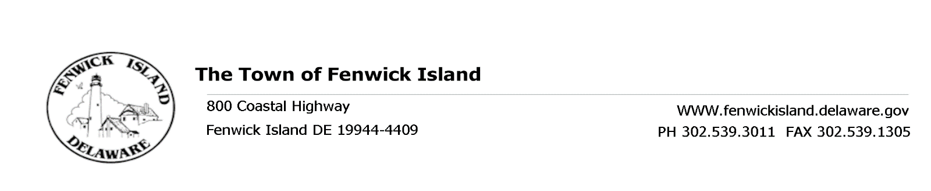
REGULAR MEETING OF THE TOWN COUNCIL
March 24, 2017, at 3:30 p.m.
Town Hall

AGENDA

Flag Salute and Call to Order
- President’s Report
- For Discussion and Possible Action:
- Workers Compensation Review and Proposal Town Manager Tieman / Terri
Desanto, DFIT Program Administrator
- Earth Day Resolution Town Clerk Poole
- Arbor Day Celebration Town Clerk Poole
- Approval of Minutes from February 24, 2017 Regular Council Meeting
- Treasurer’s Report
- Town Manager’s Report
- Department Reports: Building, Public Works, Beach Patrol and Police
- Committee Reports: Beach, Environmental, Business Development, Ad hoc Election, Planning Commission, Ad hoc Financial
- Charter & Ordinance – items for discussion and possible action to forward to Charter & Ordinance Committee for review:
  - Mechanical Equipment in Setbacks
  - Cell Phone Towers/Antennas
  - Commercial Pools - Setbacks
- Old Business
- New Business
- Upcoming Events and Meetings:
- Apr 07 9:30 a.m. Charter & Ordinance Meeting
- Apr 13 2:30 p.m. Environmental Committee Meeting
- Apr 19 2:00 p.m. Business Development Committee Meeting
- Apr 28 3:30 p.m. Regular Council Meeting
- Public Participation
- Adjournment

This Agenda is subject to change to include additional items, including Executive Sessions or the deletion of items as in accordance with provisions within Title 29, Chapter 100. Freedom of Information Act. Persons with disabilities requiring special accommodations please contact Town Hall 72 hours in advance. No video conferencing will be conducted.

Posted: March 17, 2017

