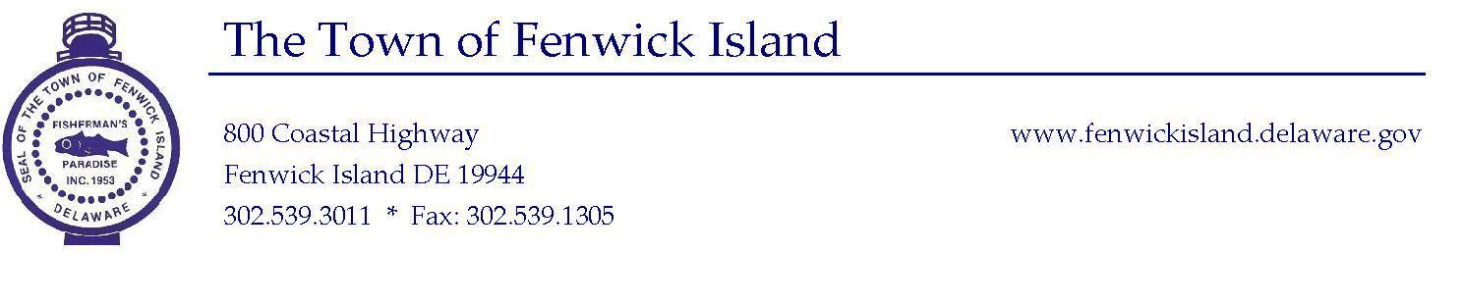
Town of Fenwick Island
Environmental Committee
April 13, 2017
2:30 pm
Town Hall

Call to Order and Flag Salute

- Approval of Minutes of March 16, 2017l

- Earth Day, Saturday, April 22, 2017

  - Set-up/Committee Assignments
  - Schedule of Events

- Old Business
  - Ad hoc Finance Committee decision about Canals Survey

- New Business

- Date of Next Meeting

- Adjournment

This Agenda is subject to change to include additional items, including Executive Sessions or the deletion of items as in accordance with provisions within Title 29, Chapter 100. Freedom of Information Act. Persons with disabilities requiring special accommodations please contact Town Hall 72 hours in advance. No video conferencing will be conducted.

Posted: April 5, 2017

