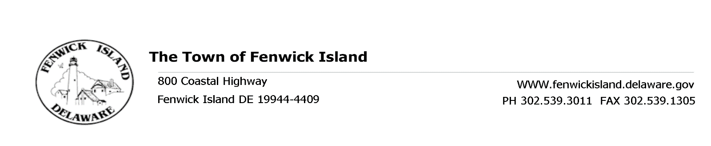
REGULAR MEETING OF THE TOWN COUNCIL
April 28, 2017, at 3:30 p.m.
Town Hall

AGENDA

Flag Salute and Call to Order

Roll Call
- President’s Report
- For Discussion and Possible Action
- Ordinance to Adopt Comp Plan Resolution #81-2017 Town Clerk Poole
- BBVFC Donation for Summer Firefighters/EMT’s Mayor Langan/Town Manager Tieman
- Fenwick Island License Plate Program Councilmember Bunting/Town Manager Tieman
- Changes to Debt Limits Allowed by Charter Councilmember Carmean/Town Manger Tieman
- Allow Welcome to F.I. on Town Message Board and Business Development Committee Chair Collins
  - Various Commercial Signs
- Mob-i-Mats Public Works Supervisor Reed
- Approval of Minutes from March 24, 2017 Regular Council Meeting
- Treasurer’s Report
- Town Manager’s Report
- Department Reports: Building, Public Works, Beach Patrol and Police
- Committee Reports: Beach, Environmental, Business Development, Ad hoc Election, Planning Commission, Ad hoc Financial and Charter & Ordinance
- Old Business
- New Business
- Upcoming Events and Meetings:
- May 12 9:30 a.m. Charter & Ordinance Meeting
- May 12 1:00 p.m. Budget Committee Meeting
- May 19 2:00 p.m. Budget Committee Meeting
- May 26 3:30 p.m. Regular Council Meeting
- Public Participation
- Adjournment

This Agenda is subject to change to include additional items, including Executive Sessions or the deletion of items as in accordance with provisions within Title 29, Chapter 100. Freedom of Information Act. Persons with disabilities requiring special accommodations please contact Town Hall 72 hours in advance. No video conferencing will be conducted.

Posted: April 21, 2017

