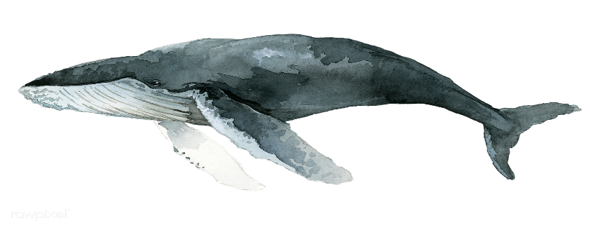
The Fenwick Island Environmental and Beach Committees are once again sponsoring
Bay to Beach Cleanup to celebrate Earth Day 2023, Saturday, April 22, 8:30 am until 10:00 am (rain or shine)

Participants will gather at Town Hall
(800 Coastal Highway in Fenwick)
for refreshments, street assignments, gloves and bags, door prize raffles and a commemorative token of appreciation.

The MERR (Maritime Education, Research and Rehabilitation) Institute will be sharing an educational display on the importance of marine mammals and the need to protect their habitat in Town Hall from 8:30 am until 11:00 am. Bring the kids!!!
Please join us in keeping Fenwick the cleanest town on the shore!

